Assignment Title: Generative Modelling Case Study
Student Name: Navaneeth Talluri
Student ID: 23102357

1. Introduction
Generative Adversarial Networks (GANs), first introduced by (Goodfellow et al., 2014) , represent a major advancement in generative modelling by enabling neural networks to learn complex data distributions without explicitly defining likelihood functions. Unlike traditional supervised learning methods, GANs operate through an adversarial process in which two neural networks a generator and a discriminator are trained simultaneously. The generator aims to produce synthetic samples that resemble real data, while the discriminator attempts to distinguish between real and generated samples. This adversarial dynamic encourages the generator to progressively improve, ultimately approximating the true data distribution(Goodfellow et al., 2014) .
Despite their conceptual elegance, GANs are known for training instability, mode collapse, and sensitivity to hyperparameters. Subsequent research has proposed several improvements, including Wasserstein GAN (WGAN)(Arjovsky, Chintala and Bottou, 2017) and WGAN with Gradient Penalty (WGAN-GP) (Gulrajani et al., 2017) , which address these limitations by introducing more stable optimization objectives.
This study explores GANs across increasing levels of complexity, beginning with synthetic data generation and progressing to real-world applications in medical imaging, cybersecurity, and creative AI. The objective is not only to implement these models but also to critically evaluate architectural choices and their impact on performance.

2. Learning GAN Behaviour Using Synthetic Data

2.1 Modelling a Noisy Sine Wave Distribution
The initial experiment focuses on learning a simple one-dimensional function embedded in two-dimensional space, defined as: y = sin(x) + ε
where ε represents Gaussian noise. This controlled setting provides a useful foundation for understanding GAN behaviour, as the true data distribution is known and easily visualised.
A fully connected neural network architecture was adopted for both the generator and discriminator. This choice is appropriate given the low dimensionality of the data and aligns with prior work suggesting that multilayer perceptrons (MLPs) are sufficient for modelling simple continuous distributions(Goodfellow et al., 2014) . The generator maps a low-dimensional latent vector to a two-dimensional output, while the discriminator evaluates the authenticity of input samples.
Training stability was improved using LeakyReLU activations, dropout regularisation, and label smoothing. These techniques are widely recommended in GAN literature to prevent discriminator overconfidence and reduce gradient saturation(Radford, Metz and Chintala, 2016) .
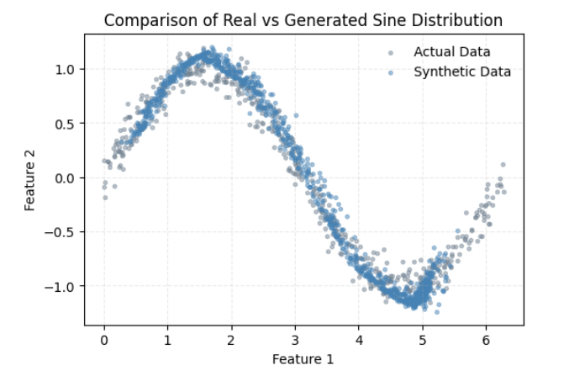
Figure 1 Real vs Generated Sine Distribution
The results indicate that the generator successfully learns the underlying sinusoidal structure. Initially, generated samples are scattered randomly, but over time they align with the true distribution. However, some discrepancies remain in capturing the noise distribution, reflecting the inherent difficulty GANs face in modelling fine-grained stochastic variation.

2.2 Conditional GAN for Parametric Curve Learning
The second experiment extends the problem to a more complex parametric function:
y = sin(2x) + 0.3cos(5x) + ε
Unlike the previous setup, this task requires learning a conditional relationship between input x and output y. A conditional GAN (cGAN) framework was therefore employed, where the generator receives both the input variable x and a noise vector z. This design enables the model to learn a mapping from x to y while still incorporating stochasticity.
Conditional GANs have been shown to be particularly effective for structured generation tasks, as they allow control over the output space while maintaining diversity(Mirza and Osindero, 2014) . In this implementation, the generator learns to approximate the conditional distribution p(y|x), rather than the joint distribution p(x, y).
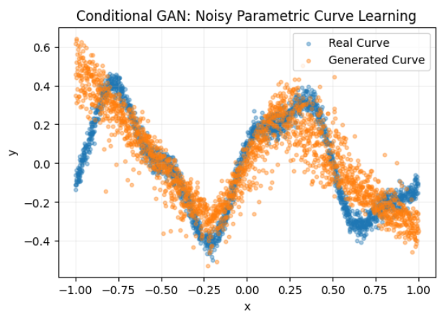
Figure 2 Real vs Generated Parametric Curve
The generated outputs demonstrate that the model captures the overall shape of the function, including its oscillatory behaviour. Nevertheless, minor deviations are observed, particularly near boundary regions. This is consistent with findings in the literature that GANs often struggle with edge cases and low-density regions of the data distribution.

2.3 Architectural Improvements and Their Impact
To enhance performance, the GAN architecture was modified by increasing network depth, incorporating batch normalisation, and applying Tanh activation in the generator output layer. These modifications are inspired by the Deep Convolutional GAN (DCGAN) guidelines proposed by(Radford, Metz and Chintala, 2016) , which emphasise stable training through architectural constraints.
Batch normalisation plays a critical role by reducing internal covariate shift, thereby improving gradient flow during training. The deeper architecture allows the model to capture more complex nonlinear relationships, while Tanh ensures that outputs are bounded within the same range as the normalised data.
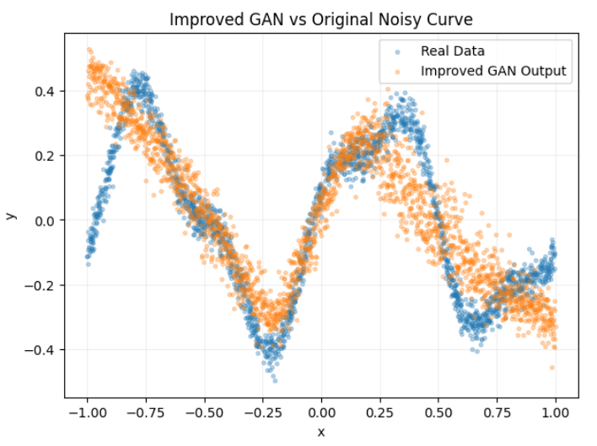
Figure 3 Improved GAN Output
The improved model demonstrates significantly better alignment with the true data distribution. The generated curve appears smoother and more consistent, indicating that the architectural enhancements effectively increased the model’s representational capacity. This result reinforces the importance of careful architectural design in GAN performance.

3. Real-World Applications of GANs

3.1 Medical Imaging with BloodMNIST
In the first real-world application, GANs were applied to medical image generation using the BloodMNIST dataset. Due to the known instability of standard GANs, the WGAN-GP framework was adopted. This approach replaces the Jensen-Shannon divergence with the Wasserstein distance, providing a more meaningful gradient signal during training(Arjovsky, Chintala and Bottou, 2017) .
The addition of a gradient penalty term further enforces the Lipschitz constraint, which is essential for the theoretical validity of WGANs(Gulrajani et al., 2017) . Unlike traditional discriminators, the critic in WGAN-GP does not use a sigmoid activation, allowing it to output unbounded real values.
Figure 4 Generated Blood Cell Images
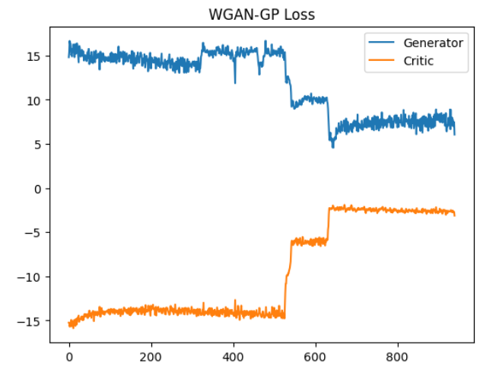
Figure 5 Training Loss Curve
The generated images exhibit realistic structural patterns, capturing key visual features of blood cells such as shape and texture. Although some blurriness is present, this is a common limitation in GAN-based image synthesis, particularly when training data is limited.
Quantitative evaluation using the Fréchet Inception Distance (FID) further supports the qualitative findings. Lower FID scores indicate that the generated images are statistically similar to real images, although perfect alignment remains challenging. The computed FID score of 419.02 is considerably high, indicating that the generated images differ significantly from real data in feature representation.

3.2 Synthetic Network Traffic Generation (CICIDS 2017)
GANs were also applied to tabular cybersecurity data from the CICIDS 2017 dataset. Unlike image data, tabular data presents unique challenges due to mixed feature distributions and the absence of spatial structure. Nevertheless, GAN-based approaches have been increasingly explored for data augmentation and anomaly detection in cybersecurity contexts.
A multilayer perceptron architecture was used for both generator and discriminator. The goal was to generate synthetic network traffic that preserves the statistical properties of real data, particularly for imbalanced classes such as attack traffic.
Evaluation was conducted using t-SNE visualisation and statistical measures including mean difference, standard deviation difference, and Kolmogorov–Smirnov (KS) statistics
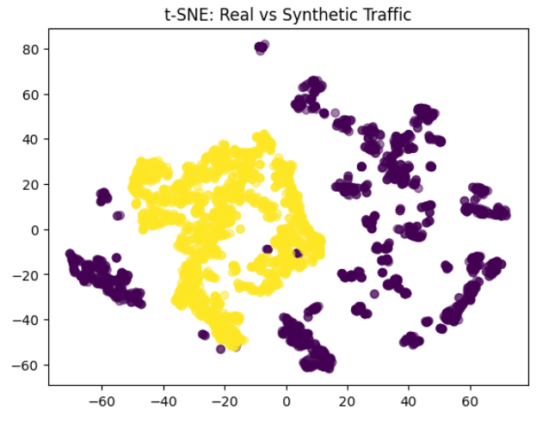
Figure 6 t-SNE Plot
The t-SNE results show a significant overlap between real and synthetic samples, suggesting that the GAN successfully learned the underlying feature distribution. Additionally, small mean and variance differences indicate good statistical alignment. These findings highlight the potential of GANs for privacy-preserving data generation and dataset balancing.

3.3 Creative AI: Sketch Generation with QuickDraw
The final application explores GANs in a creative context using the QuickDraw dataset. Stroke-based drawings were converted into image representations and modelled using a Deep Convolutional GAN (DCGAN).
DCGANs are particularly well-suited for image generation tasks due to their ability to capture spatial hierarchies through convolutional layers(Radford, Metz and Chintala, 2016) . The generator uses transposed convolutions to upsample latent vectors, while the discriminator applies convolutional filters to classify images.
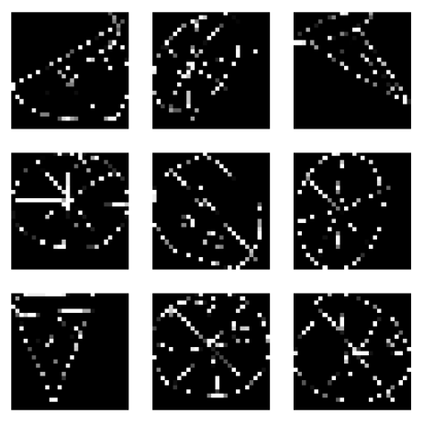
Figure 7 Generated Pizza Sketches
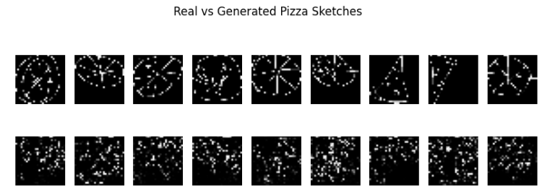
Figure 8 Real vs Fake Comparison
The generated sketches demonstrate that the model learns the general structure of pizza drawings, including circular shapes and topping patterns. However, variability remains high, and some outputs appear noisy or incomplete. This reflects the inherent diversity and ambiguity of hand-drawn data.

4. Conclusion
This study demonstrates the versatility of GANs across a range of applications, from simple mathematical functions to complex real-world datasets. The findings emphasise that successful GAN implementation requires careful consideration of architecture, training strategy, and evaluation methods.
While GANs remain a powerful tool for generative modelling, ongoing research continues to address their limitations. Emerging approaches such as diffusion models may offer more stable alternatives, but GANs remain highly relevant due to their efficiency and flexibility.

References
Arjovsky, M., Chintala, S. and Bottou, L. (2017) Wasserstein GAN. Available at: https://arxiv.org/abs/1701.07875
Goodfellow, I.J. et al. (2014) Generative Adversarial Networks. Available at: https://arxiv.org/abs/1406.2661
Gulrajani, I. et al. (2017) Improved Training of Wasserstein GANs. Available at: https://arxiv.org/abs/1704.00028
Mirza, M. and Osindero, S. (2014) Conditional Generative Adversarial Nets. Available at: https://arxiv.org/abs/1411.1784
Radford, A., Metz, L. and Chintala, S. (2016) Unsupervised Representation Learning with Deep Convolutional Generative Adversarial Networks. Available at: https://arxiv.org/abs/1511.06434

